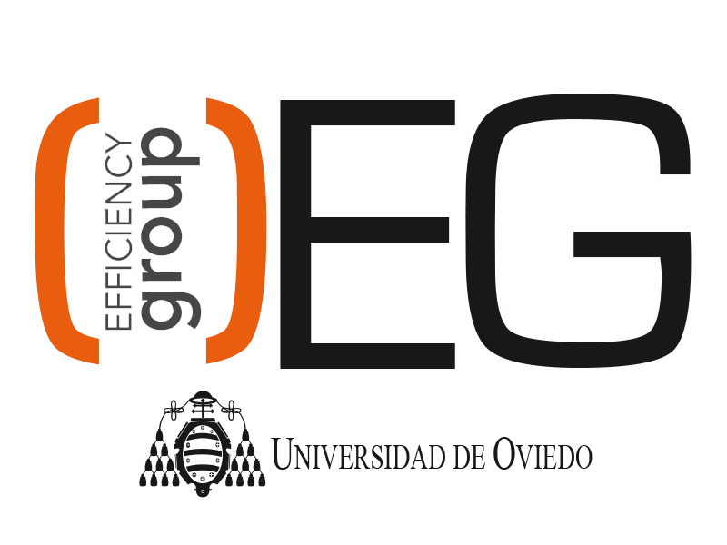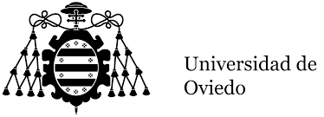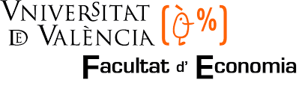

Dear colleague,
I am glad to announce the 2nd International Seminar on Water Resources Management which will be held in Oviedo (University of Oviedo, Spain) on 28-29th June 2016.
This year’s topic will be “Integrated water resources management: tools and institutions”. Climate change, growing demand and water pollution are common causes of water stress, shortages and unsustainable water use. As a consequence, water resources management is one of the most relevant issues in the policy agenda. Different tools and institutional frameworks have been used in order to solve the most significant problems in this field. The Organizing Committee invites you to submit original contributions on related topics to water resources management. The outcomes of the workshop will be:
- The outline of an international research agenda on water resources management
- The building of a platform for on-going discussion and collaborations
- Joint international publications
Organizing Committee
María A. García-Valiñas, Javier Suárez-Pandiello (University of Oviedo), Marta Suárez-Varela (University of Valencia)
Scientific Committee
Rui Cunha Marques (University of Lisbon), Andrea Guerrini (University of Verona), Giulia Romano (University of Pisa), Andrés Picazo-Tadeo (University of Valencia)
The University of Oviedo and the Oviedo Efficiency Group
The University of Oviedo (http://www.uniovi.es/en) is a public institution of higher education and research with several campus and buildings spread along four cities of Asturias region. With over 400 years of history, it offers a full range of undergraduate degrees adapted to the European Higher Education Area (EHEA) in all branches of knowledge and postgraduate degree programmes.
The Oviedo Efficiency Group (OEG, http://www.unioviedo.es/oeg/) comprises a group of researchers working in the fields of efficiency and productivity analysis. The large number of articles published in top international journals shows the international quality of the Group. In early 2015, the Group began collaborating with the Cluster of Energy, Environment and Climate Change created by the University of Oviedo through the framework of the Campus of International Excellence project.

About Oviedo and surroundings
Asturias is a lovely region located in northern Spain, and Oviedo is the capital of the region. For further information about this region, please check https://www.turismoasturias.es/en/home-en .
Application process and deadlines
There is no registration fee and we will provide contributors with coffee, snacks and meals during the Seminar. Please, take note of these important dates:

- The deadline for submission of extended abstracts (max. 1000 words, excluding references) ends on 20th March 2016. Please send your extended abstracts to mariangv@uniovi.es. Late applications will not be considered.

- The decision on the acceptance of abstracts will be notified by 15th April 2016. Since it is a small-size event, and depending on the number of contributions finally submitted, it is possible that we might be forced to select the contributions to be presented in the Seminar.

- The full paper (or the final power-point presentation) should be submitted by 20th June 2016.

More details about conference venue and other logistic issues will be provided latter. In any case, for further information about the meeting, the Organizing Committee is available through the e-mail mariangv@uniovi.es.
We are looking forward to meeting you in Oviedo,

Best Regards,
The Organizing Committee

